CO4-PROGRAMS & OUTPUTS
import React, { useState } from "react";
function App() {
// Cart state in parent component
const [cart, setCart] = useState([]);
// Function to add product to cart
function addToCart(product) {
setCart([...cart, product]);
}
return (
<div style={{ padding: "20px" }}>
<h1>Gnane's Simple E-Commerce App</h1>
<h2>Products</h2>
{/* Child Components */}
<Product
name="Laptop"
price={50000}
addToCart={addToCart}
/>
<Product
name="Mobile"
price={20000}
addToCart={addToCart}
/>
<Product
name="Headphones"
price={3000}
addToCart={addToCart}
/>
<Cart cart={cart} />
</div>
);
}
// Product Component
function Product(props) {
return (
<div
style={{
border: "1px solid black",
padding: "10px",
margin: "10px",
width: "200px"
}}
>
<h3>{props.name}</h3>
<p>Price: ₹{props.price}</p>
<button
onClick={() =>
props.addToCart({
name: props.name,
price: props.price
})
}
>
Add to Cart
</button>
</div>
);
}
// Cart Component
function Cart(props) {
return (
<div>
<h2>Cart Items</h2>
{props.cart.length === 0 ? (
<p>Cart is Empty</p>
) : (
props.cart.map((item, index) => (
<div key={index}>
{item.name} - ₹{item.price}
</div>
))
)}
</div>
);
}
export default App;
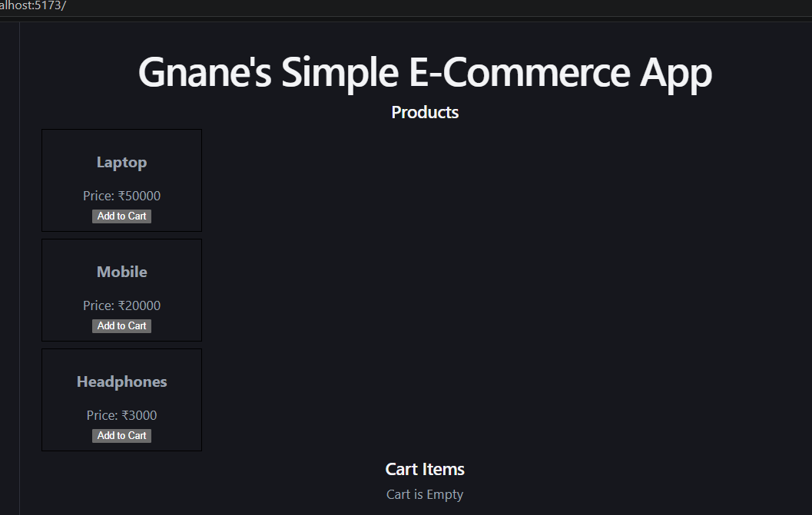
import { useState } from "react";
function App() {
return (
<div>
<h1>Gnane's Amazon Store</h1>
<SearchBox />
</div>
);
}
function SearchBox() {
// State kept close to where it is used
const [search, setSearch] = useState("");
return (
<div>
<input
type="text"
placeholder="Search products"
value={search}
onChange={(e) => setSearch(e.target.value)}
/>
<p>Searching for: {search}</p>
</div>
);
}
export default App;

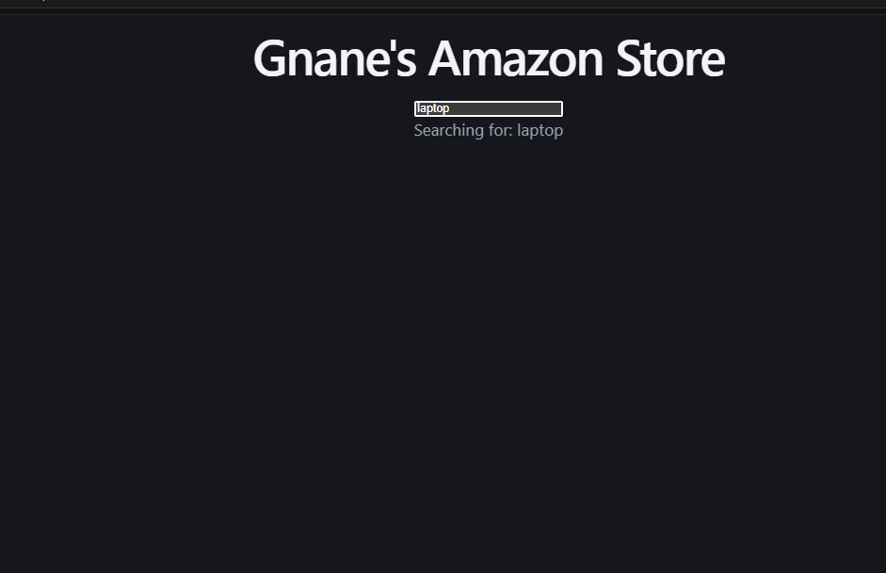
import { useState } from "react";
function App() {
return (
<div>
<h1>Gnane's Amazon Store</h1>
<SearchBox />
</div>
);
}
function SearchBox() {
// State kept close to where it is used
const [search, setSearch] = useState("");
return (
<div>
<input
type="text"
placeholder="Search products"
value={search}
onChange={(e) => setSearch(e.target.value)}
/>
<p>Searching for: {search}</p>
</div>
);
}
export default App;

import React, { useState } from "react";
function App() {
return (
<div>
<h1> Gnane's E-Commerce Store</h1>
<Product name="Laptop" />
<Product name="Mobile" />
</div>
);
}
function Product(props) {
// Separate state inside each product
const [count, setCount] = useState(0);
return (
<div>
<h3>{props.name}</h3>
<p>Cart Count: {count}</p>
<button onClick={() => setCount(count + 1)}>
Add to Cart
</button>
<hr />
</div>
);
}
export default App;
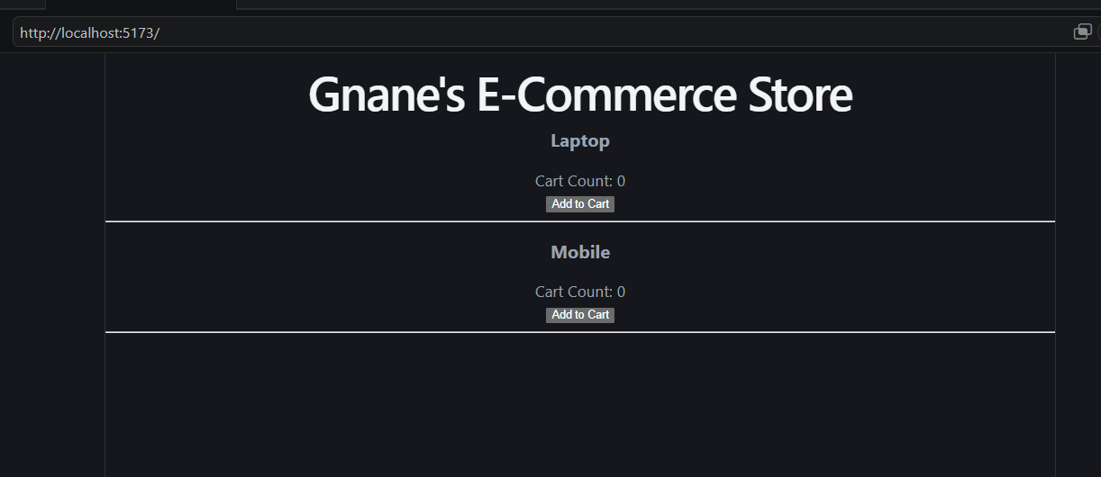
import { createContext, useContext } from "react";
// Create Context
const UserContext = createContext();
function App() {
const username = "Gnane";
return (
<UserContext.Provider value={username}>
<Parent />
</UserContext.Provider>
);
}
// Parent Component
function Parent() {
return (
<div>
<Child />
</div>
);
}
// Child Component
function Child() {
return (
<div>
<GrandChild />
</div>
);
}
// GrandChild Component
function GrandChild() {
// Access global data directly
const username = useContext(UserContext);

return (
<h2>Welcome {username} using ReactContext</h2>
);
}
export default App;
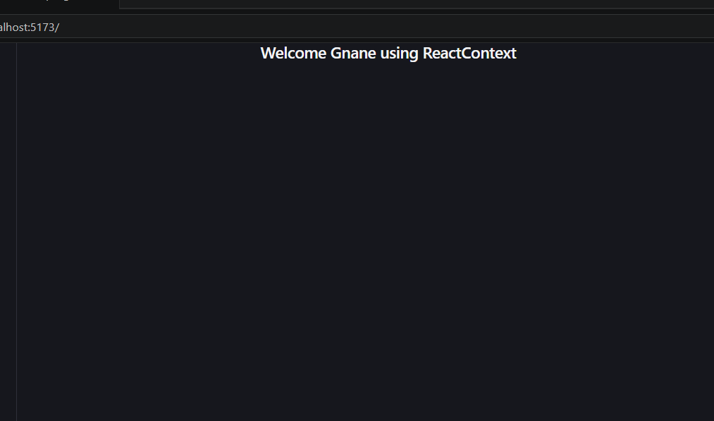
import React, { useEffect, useState } from "react";
import { getUsers } from "./apiService";
function App() {
const [users, setUsers] = useState([]);
useEffect(() => {
async function fetchData() {
const data = await getUsers();
setUsers(data);
}
fetchData();
}, []);
return (
<div>
<h1>User List</h1>
{users.map((user) => (
<p key={user.id}>
{user.name}
</p>
))}
</div>
);
}
export default App;
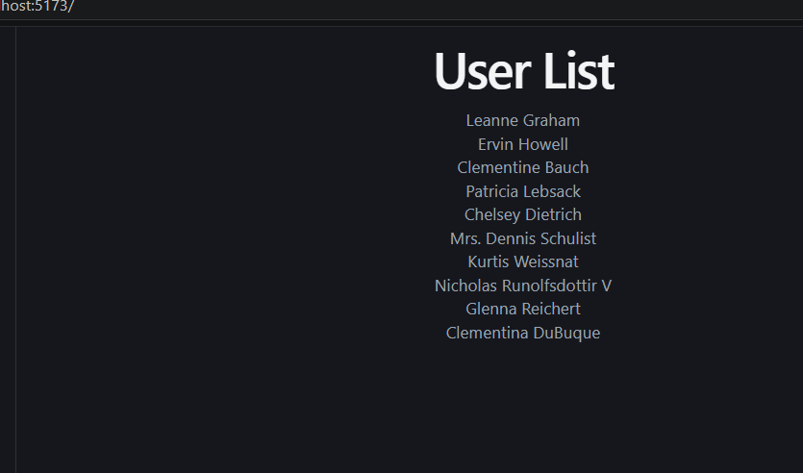
import { useEffect, useState } from "react";
function App() {
const [user, setUser] = useState(null);
const [posts, setPosts] = useState([]);
useEffect(() => {
async function loadData() {
// Step 1: Get user
const userResponse = await fetch(
"https://jsonplaceholder.typicode.com/users/1"
);
const userData = await userResponse.json();
setUser(userData);
// Step 2: Get posts of that user
const postResponse = await fetch(
`https://jsonplaceholder.typicode.com/posts?userId=${userData.id}`
);
const postData = await postResponse.json();
setPosts(postData);
}
loadData();
}, []);
return (
<div>
<h2>User Details</h2>
{user && <p>Name: {user.name}</p>}
<h2>Posts</h2>
<ul>
{posts.map((post) => (
<li key={post.id}>{post.title}</li>
))}
</ul>
</div>
);
}
export default App;
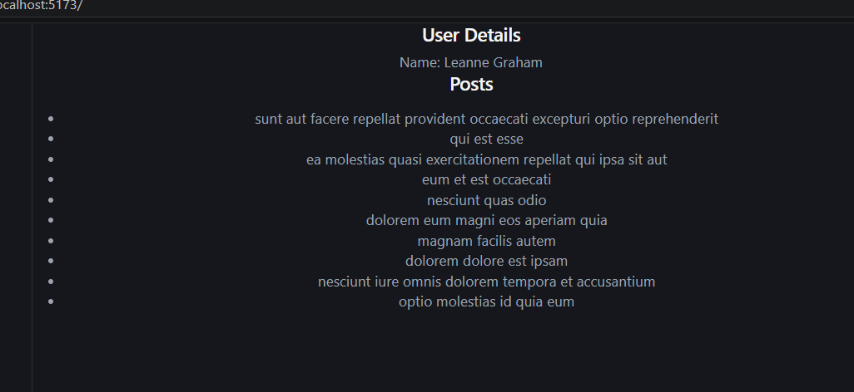
import { useState } from "react";
function App() {
const [cartCount, setCartCount] = useState(0);
function addTwoItems() {
setCartCount(cartCount + 1); // 1
setCartCount(cartCount + 1); // 0+1=1
}
return (
<div>
<h2>Gnane's Cart Items: {cartCount}</h2>
<button onClick={addTwoItems}>Add Two Products</button>
</div>
);
}
export default App;
